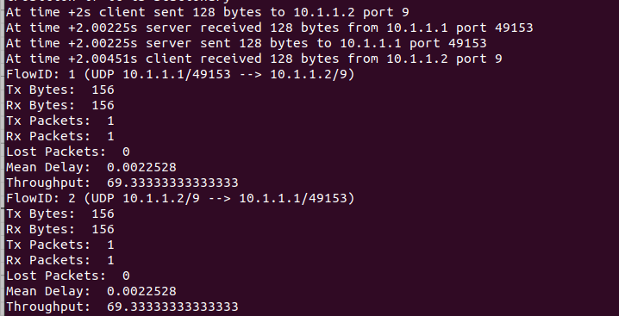
Data Size : 128 Bytes

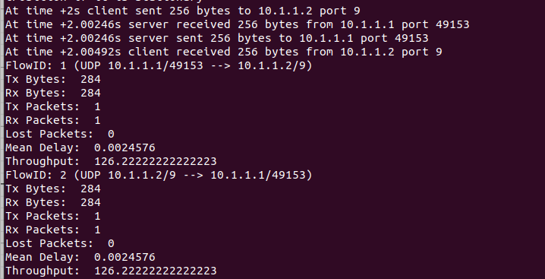
Data Size : 256 Bytes

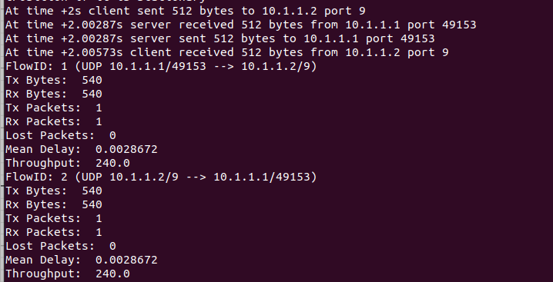
Data Size : 512 Bytes

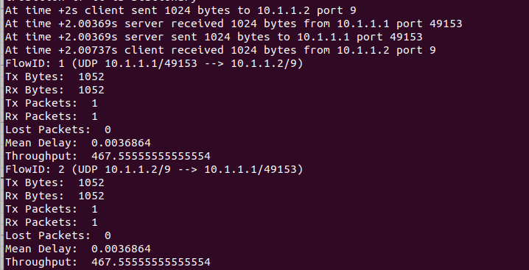
Data Size : 1024 Bytes

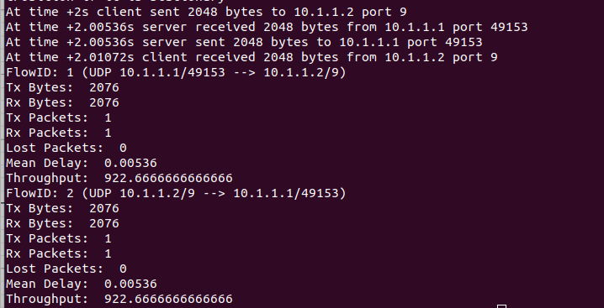
Data size : 2048 bytes

A throughput vs data size graph

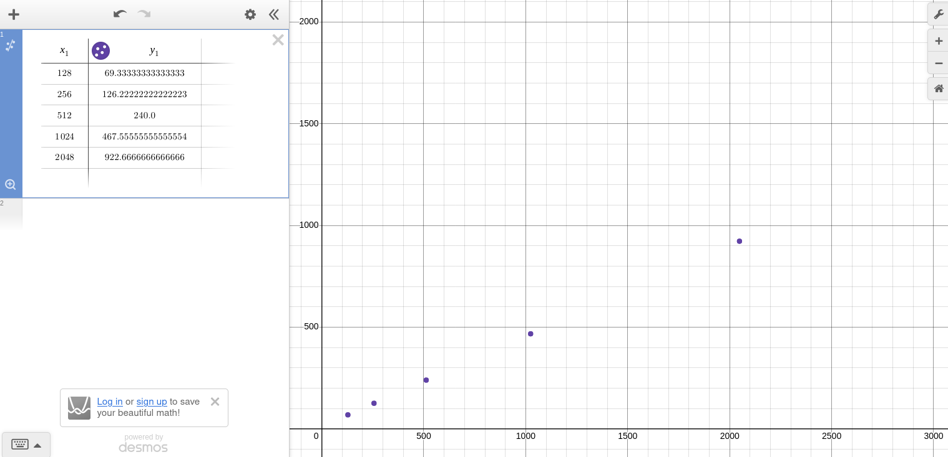

This graph shows the relationship between throughput, which is plotted on the Y-axis, and data size, which is plotted on the X-axis. As data size increases, throughput also increases, indicating a positive trend.

